

ONTOLOGIES IN RISK MANAGEMENT
Milan KONECNY¹, Tomas REZNIK²
¹konecny@geogr.muni.cz, ²tom@mail.muni.cz
Masaryk University, Faculty of Science, Department of Geography,
Laboratory on Geoinformatics and Cartography
Kotlarska 2, 611 37 Brno, Czech Republic

INTRODUCTION
The problem of syntactic heterogeneity among geographic datasets has emerged as a result of native data formats and the development of monolithic and proprietary systems. The World Wide Web (WWW) supplies the basic infrastructure for the distributed use and multiple exploitation of data and systems (systems interoperability). Geoinformation technology standards developed by the Open Geospatial Consortium (OGC) and the International Organization for Standardization (ISO) provide the basis for syntactic interoperability and cataloguing of geographic data and geographic information services. Spatial Data Infrastructures (SDIs) show what can be accomplished by this approach, but also raise challenging interoperability issues (Bernard et al. 2003). Although SDIs provide the basis for syntactic interoperability the usability of information that is created in one context is often limited use in other contexts. One important reason for this is semantic heterogeneity. This problem could be solved using ontologies and their implementation in the context of cartographic visualization.
The first step is to identify and analyze existing problems caused by semantic heterogeneity in several risk management use cases. Based on these results of this analysis, the project will focus on developing methods for overcoming these problems during service discovery, composition and execution within SDIs. The viability of the developed approaches will be illustrated by prototypically implemented web services for intelligent search and semantic translation and by applying them to the use cases. This paper will describe the basis of the context cartographic visualization and also ontologies with focus on geographic ontologies.

SEMANTIC ONTOLOGIES
Ontology is a widely used term. From an informatics’ point of view, ontology is described as a formal and explicit specification of a conceptualization (Gruber, 1995). Conceptualization refers to an abstract model of how people think about real things in the world. Explicit specification means that the concepts and relations of this abstract model have been given explicit names and definitions. Formal means that the definition of a term is written down in a formal language (see below) with well-understood properties; very often this is a logic-based language. The main advantage of using a language of this kind is the avoidance of ambiguities of concepts.
Problems of semantic heterogeneity result from the fact that the terms from a certain vocabulary (e. g. that used in a catalogue) are just words with an implicit meanings (for humans), but without an explicit meaning (which machines are able to understand). Therefore, we propose the usage of concepts that are clearly defined by ontologies to circumvent the ambiguities that otherwise emerge.
This has several significant advantages. First, it becomes possible to translate a term (i.e. a concept) from one vocabulary (i.e. one ontology) into a term from another vocabulary. When two terms are found to be equal because they are specified by the same definition, this is called a “mapping”: one concept is mapped onto another.

Secondly, ontologies can be used to derive super-concept and sub-concept relationships. Terminological reasoning engines can automatically construct hierarchies of concepts by examining their definitions. This makes it possible to “translate” a superordinate, general term into one or more subordinate, more specific terms, which can even come from different vocabularies – as long as these vocabularies are built up on the same basic definitions. Further in-depth information about ontologies and their general use for knowledge representation, semantic translation and semantic integration can be found in Wache et al. 2001.

Representation of ontology
There is a need for explicit specification of ontology that supports semantic understanding, sharing and syntactic exchange between different users and databases. The basic requirement is the possibility of ontology formulation in other languages (see Figure 2). Various languages have been used in the literature for specifying ontologies. Some languages are based on XML, such as XOL [www.ai.sri.com/~pkarp/xol], SHOE [www.cs.umd.edu/projects/plus/SHOE/spec1], OML [www.ontologos.org/CKML/CKML%200.2.html], RDF [www.w3.org/TR/PR-rdf-syntax] etc, some are based on Description Logics (DLs), e.g. KIF, CycL [http://www.cyc.com/cycl.html], CLASSIC, and some are built based on both of XML and DLs, e.g. OIL, DAML+OIL, OWL [http://xml.coverpages.org/owl.html]. These languages are divided according to the formalization rate: very informal (e.g. ontologies expressed in native language), semi-formal (e.g. ontologies expressed in native language but in restricted structure) and formal (these languages are formed only with defined terms; many formal ontologies contain also informal ontology – particular concepts have a documentation component that allows presentation of its content with native language). A language for ontologies should be:
- compatible with existing web standards – like XML, RDF, RDFS – because of interoperability within information exchange
- sufficient for the formulation of ontology
- formally specified for computer processing
- support editing and import of ontologies
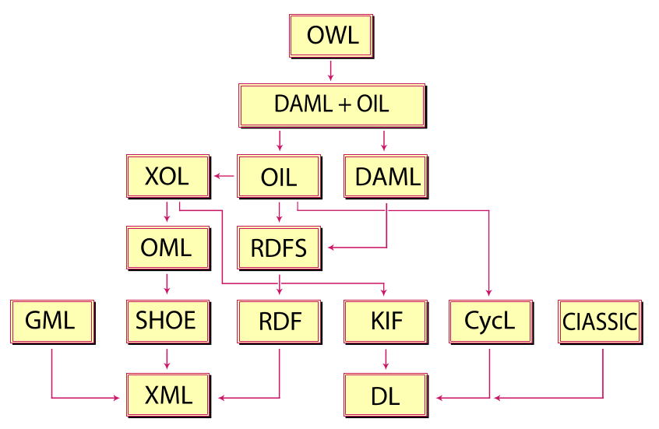

Figure 1 – Ontology language hierarchy.

Intelligent search and translation of (meta)data
The searching tasks in our case can be divided into two fields: the search for services and search for data. Both depend on descriptions by “rich” metadata which take their content from catalogues. In our approach, the catalogues are in fact ontologies with clearly defined concepts.
Although the services and data may be described by totally different words, the search engine is able to detect the super- and sub-concept relationships and presents more and better results. Therefore, this technology is called “intelligent search”. Accordingly, a catalogue service, which was extended in similar way, is called “intelligent catalogue service”.
Ontologies can be also used to overcome the problems that have been identified with data or metadata fusion. For example, when creating consistent derived map, we must translate all categories of each layer to a terminology from different levels of granularity. This approach is typical for risk management – there are composed data across many data sources from all levels (local, regional, global). After the concepts explicitly sign the terms, software will be able to find super- and sub-concept relationships. Thus very exact classification category (e.g. stream courses) can be translated to the more general term (e.g. continental waters). This procedure is called translation by re-classification.

Time aspect
A characteristic of all geographical facts is that they are embedded not just in space but also in time. Settlements and other topographic features have some time of origin (though it may not always be known) and in some cases dissolution. The names of many places have changed over time and geopolitical and natural environmental boundaries are subject to appearance, disappearance or re-location over time. Full support for spatio-temporal information is highly desirable in a geographical ontology for purposes of information retrieval. Time is more important in risk management, where early operations are more successful.

Geographic ontology
A key aim in geographic ontology is the development of a search engine that displays some intelligence in the interpretation of geographical terminology. The assumption is that people may wish to find information about something that relates to somewhere. The most common way to refer to a location is to use place names, which may be qualified by spatial relationships (such as in or near). In order to assist in recognizing place names and spatial relationships when they are employed in a search engine query, it is proposed to employ an ontology which encodes geographical terminology and the semantic relationships between geographical terms. The idea is that the geographical ontology will enable the search engine to detect that the query refers to a geographic location and to perform a search which will result in the retrieval and relevance ranking of web resources that refer both exactly and approximately to the specified location. This will entail retrieval of resources that refer to alternative versions of a specified place name as well as to the places that are spatially associated with it through relations such as those of containment and adjacency. It is also proposed that ontology should be used to assist in a process of metadata extraction whereby the geographical context of resources is determined for the purpose of search engine indexing as well as providing the potential to annotate a resource to improve its future geographical visibility.

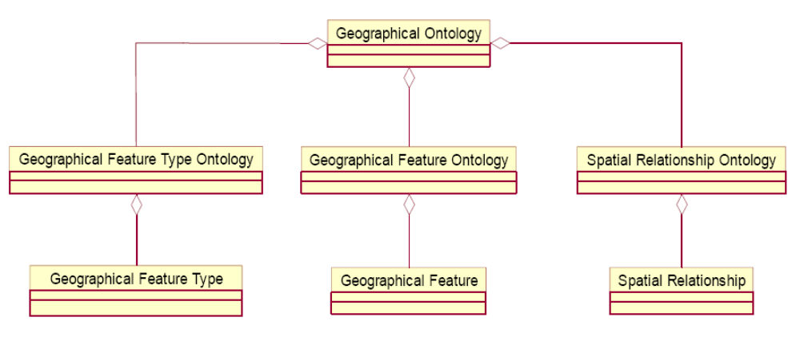
Figure 2 – UML diagram of geographical ontology.

The first component of the geographic ontology (Figure 3) is the geographical feature type ontology which encodes the various feature types which each geographic feature instance falls into. The second component is the geographical feature ontology which encodes the concrete feature instances in a given geographical space. The geographical ontology represents an effective way for encoding geographic features. First, it encodes both meta-level (geographical feature types and spatial operators) and data-level (geographical features) information, and two levels are closely related to each others through the feature type that an individual feature instance belongs to and spatial relationships that an individual feature instance may have. Consequently, it supports intelligent interpretation of place name, place type and spatial operators. Aside from geographic ontology, we can find cartographic ontology which is de facto context cartographic visualization.

Semantic generalization
Another aspect of generalization concerns the semantic level of detail. Most significant topographic features can be allocated to levels of detail within semantic hierarchies or classification systems. Thus, high level classes might include countries, cities, primary roads, major rivers and mountains ranges. Lower levels include counties, towns, secondary roads, tributaries and individual mountains. More detailed semantic levels could include individual buildings, side streets, minor streams and small hills. In general it can be assumed that people are interested in information at different levels of semantic detail. In order to be really useful and beneficial, the ontology should therefore be able to encode geographic data at multiple levels of semantic generalization.

Explicit vs. implicit maintenance of spatial data
There are several types of spatial information, ranging from coordinate-based geometry in the form of points, lines, areas and volumes, to the spatial relationships categorized as topology, proximity, orientation and size. The question arises as to what is an appropriate balance between explicit storage of spatial information and the use of online procedures to derive or deduce information from what is stored. In general the spatial relationships can be derived from the coordinate geometry data. Correct determination of topological relationships can however require detailed and accurate coordinate data and can be a computationally expensive task. Computation of the other spatial relationships can in contrast be performed with less detailed geometry. Reduction in detail of the geometry may result in a degradation of the quality of the resulting relationships but because of their numerical nature it may be argued that they can tolerate some degradation while remaining useful. This differs from the determination of topological relationships which, because of their categorical (nominal) nature, are typically either true of false. Because of the high storage costs of detailed geometry and the associated computational costs, there is an argument for explicit storage of topological relationships between neighbouring objects. As indicated above, topological relationships between non-neighbouring objects can often be deduced reliably with spatial reasoning rules. From a computational point of view there might be a case for explicit storage of proximal, orientation and size relationships, at least between neighbouring objects. Clearly, this would result in a significant storage overhead. It is also the case however that logical deduction of these relationships (apart from size) between non-neighbouring objects cannot be performed reliably, due to the often imprecise nature of the relations. The cost of explicit storage of all possible such relationships would be combinatorially explosive. There is clearly merit in performing a detailed analysis of the relative costs of different storage strategies but this has not yet been done. Following the above considerations it appears reasonable therefore to decide initially to store geometry at variable levels of detail in addition to storing topological relationships between neighbouring spatial objects. The balance between online computation and explicit storage of other spatial relations and of more detailed geometry can then be examined at the implementation stage.

ONTOLOGY DESIGN
Different ontologies are typical for various subject fields. It is necessary to create a questionnaire for better understanding between different ontologies. This questionnaire is the key for formalization of roles and tasks of different kinds of people in risk management. Each task has its own purpose. It means that scale and content are different. The basic aim is to prepare appropriate form of visualization instead of having many standalone heterogeneous data sources. This cartographic visualization is so-called transformation bridge between heterogeneous data sources and the end user (rescue worker, policeman, mayor,…). This transformation bridge could be mentally created and used by the intervening worker. For example a rescue worker uses certain data for certain situation. Using some data and not using another data means specific kind of (mental) transformation bridge.
Basic approach for building of ontology is analyzing needs and data. We have to offer some possibilities of transformation bridges. This could be done for example by an interview with specific group of people. Before we start this interview, we must consider roles and tasks for each participant. In our case we take into consideration one person from: integrated rescue system (paramedics, police and firemen), intervening risk management experts and public administration (such as the mayor). We must ask explicit questions about situations they have to solve and support which they need. This should be done with a relatively small group of people. The next step is the formalization of these answers. Formalization is necessary for creation of almost closed questionnaire. Almost closed questionnaire means that there are mostly questions with preset answers. Interviewed person answers the question e. g. “How often do you use information from database XY?” Preset answers are: “never”, “rarely”, “often” and “always”. The biggest advantage of closed questions is a possibility for (statistic) processing. On the other hand, opened questions allow obtaining new kind of information. However, answers from one question are in this case too heterogeneous for processing. That is the main reason for production of the almost closed questionnaire with only explicit defined degrees of freedom.
Second level is a formalized questionnaire for significant group of people. This group of people is wider than the previous one. This questionnaire should cover all levels of risk management. Between fifty and seventy-five percent of all questions should be closed. This questionnaire should be interviewed. This is way to be sure about the quality of the answers. The final step is creation of the ontologies itself. However, the final step is not the only one. There are many final steps, because it is impossible to create ontology for the first time. We have to review and update created ontology.

CONCLUSION AND FUTURE WORK
We have presented a use case from the area of risk management that illustrates the benefits of using ontologies in context cartographic visualization. We also reviewed various ontology languages used in the literature for expressing ontologies and proposed that DAML+OIL is a suitable language for specifying the ontology. The approaches that already exist or are currently discussed can solve problems caused by syntactic heterogeneity. However, there are a number of semantic heterogeneity problems to be solved. We have sketched an approach for addressing these remaining problems that makes use of ontologies for intelligent search, semantic translation and semantic integration. In order to do so, a number of open research questions have to be addressed, e.g.:
- What are the specifics of dealing with heterogeneous service rather than data sets?
- How can the presented approach for intelligent searching be integrated with existing data and service catalogues?
- How can the presented approach for semantic translation be implemented as a web service?
- How can services for analysis and processing be combined with such a semantic translation service?
- Concrete algorithms have to be designed to implement a set of functions for accessing, query and processing of information in ontology.

All described research is just the first stage of the project. Ontology design is the basic step for context cartographic visualization. This in practice means testing different kinds of Web services with integrated ontology. This testing procedure starts while using mobile server with mapping applications and covering potentially affected area with wireless network that is able to support communication between all devices in rescue operation. After this, we should implement context cartographic visualization principles into the web services. This research has been supported by funding from Project No. MSM0021622418 called Dynamic geovisualization in risk management.

REFERENCES:
- BERNARD L. et al.: Ontologies for Intelligent Search and Semantic Translation in Spatial Data Infrastructures, In Proceedings of 6th AGILE Conference on Geographic Information Science, 2003.
- BORST, W. Construction of Engineering Ontologies for Knowledge Sharing and Reuse [Ph.D. thesis], University of Twente, Enschede, 1997.
- FU, G., ABDELMOTY, A., JONES, C.: Spatially-Aware Information Retrieval on the Internet (SPIRIT). 2003.
- GRUBER, T.: Toward Principles for the Design of Ontologies Used for Knowledge Sharing, International Journal of Human-Computer Studies, 43, 5-6 (1995).
- IGLESIAS, G., KUHN, W., WINTER, S., ZLATANOVA, S.: GI for the public: Terrorist attack in London. Geoinformatics, 7 – October/November, 18-21 (2005).
- RAPANT, P.: Interoperability in the sphere of geoinformatics and geoinformation technologies, URL: <http://gis.vsb.cz>.
- REZNIK, T. et al.: Prispevek ke kartograficke vizualizaci v krizovem rizeni. In Proceedings Geoinformatika ve statni sprave, CAGI, Brno 2006.
- SVATEK, V.: Ontologie a WWW [seminar thesis], URL: <http://dsic.zapisky.info/>.
- USCHOLD, M., GRUNINGER, M.: Ontologies: Principles, Methods and Applications, The Knowledge Engineering Review, 11(2), 93-136 (1996).
- WACHE et al.: Ontology-Based Integration of Information – A Survey of Existing Approaches. In IJCAI-01 Workshop: Ontology and Information Sharing, 2001.
- ZLATANOVA, S., HOLWEG, D.: 3D Geoinformation in emergency response: a framework. In Proceedings of the Fourth International Symposium on Mobile Mapping Technology, Kunming, 2004.

